**96boards TB-96AI AI** **Developer Kit Rockchip RK3399Pro**

* TB-96AI RK3399 Pro is a powerful core board for artificial intelligence
* Super small size and super high a calculation force is easy to develop
* **Price:** $144 - $200
* **Applications:** Widely used in AI applications such as industrial automation, UAV, image detection, face recognition, edge computing gateway, cluster server, Intelligent Quotient display, automatic driving, medicine. Application needs of market segments such as health care equipment, robots and intelligent retail.

1. **Six-core High-performance AI Core Board**

* High-performance AI processor RK3399Pro,
* Integrated neural network processor NPU, supports 8Bit/16Bit operation with computing power up to 3.0Tops to meet various visual and audio AI applications.
* TB-96AI core board can be combined with the carrier board to form a complete industrial application board, which enable it to be applied flexibly on a variety of smart products.

1. **High-performance AI Processor RK3399Pro**

* Big and little core processor architecture of ARM dual-core Cortex-A72 and quad-core Cortex-A53 at a high frequency as 1.8GHz and 1.4GHz respectively.
* integrated Mali-T860 MP4 quad-core graphics processor with powerful general-purpose computing performance.

1. **Powerful Hardware Decoding Capability**

Supports multiple display output interfaces of DP1.2, HDMI 2.0, MIPI-DSI, eDP, embed two VOPs, support dual-screen simultaneous/dual-screen display, supports 4K VP9, 4K 10bits H265/H264 and 1080P multi-format (VC-1, MPEG- 1/2/4, VP8) video decoding, 1080P (H.264, VP8 format) video coding

1. **Support Multiple AI Framework**

Compatible with multiple AI frameworks, supports TensorFlow Lite/Android NN API, AI software tools support import, mapping, and optimization of Caffe / TensorFlow models, allowing developers to use AI technology easily.

1. **Rich Extension Interfaces**

Rich in interfaces such as I2C, SPI, UART, ADC, PWM, GPIO, PCIe, USB3.0, I2S

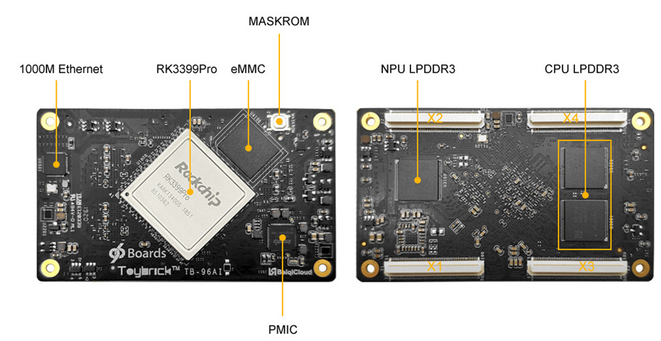

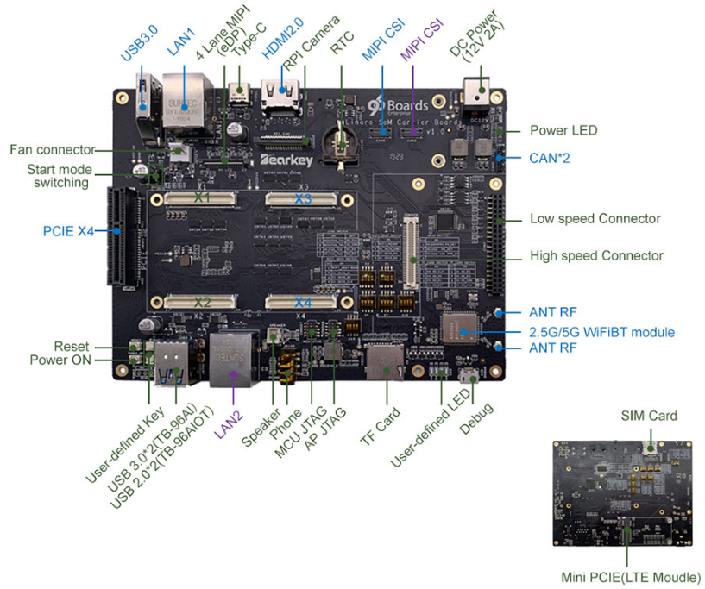

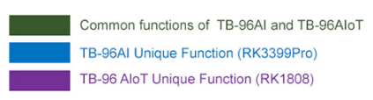

**Supporting evaluation base plate: It can be used with any of the** **following two core boards**

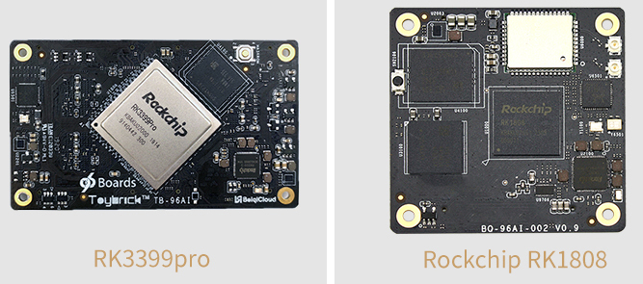

**Main Development Board: RK3399pro** **core board + Carrier Board**

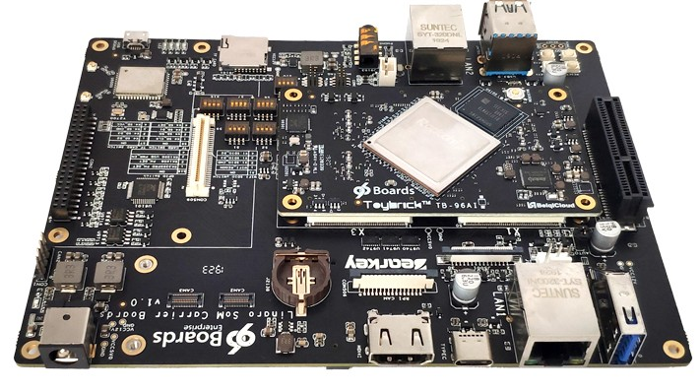

**Applications**

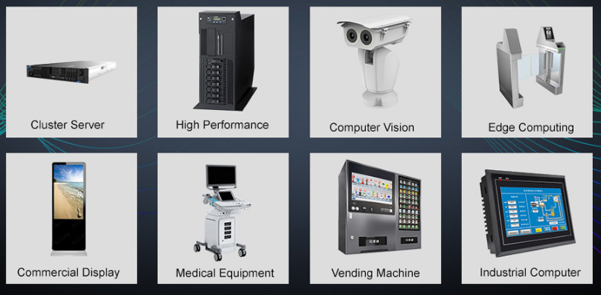

**Additional Information**

|  |  |
| --- | --- |
| **Component** | **Description** |
| **SoC:** | Rockchip RK3399Pro with Dedicated NPU |
| **CPU:** | Dual-core Cortex-A72 up to 1.8GHz Quad-core Cortex-A53 up to 1.4GHz |
| **GPU:** | ARM® Mali-T860 MP4 Quad-core GPU Supports OpenGL ES1.1/2.0/3.0/3.1, OpenVG1.1, OpenCL, DX11, Support AFBC (frame buffer compression) |
| **NPU:** | Support 8bit/16bit computing, AI computing power up to 3.0TOPs Full load computing power, low load operation power consumption is low Compatible with Caffe/Mxnet/TensorFlow model, support multi-class framework, support mainstream layer type, easy to add custom layer Provides easy-to-use development tools, PC-based model conversion, performance estimation, and accuracy verification Provides AI application development interface: support Android NN API Provides RKNN cross-platform API, Linux supported TensorFlow development |
| **VPU:** | Support 4K VP9 and 4K 10bits H265/H264 video decoding, up to 60fps 1080P multi-format video decoding (WMV, MPEG-1/2/4, VP8) 1080P video encoding, support H.264, VP8 format Video post processor: de-interlacing, denoising, edge/detail/color optimization |
|  |  |
| **RAM:** | Optional configuration with the following options: 3GB LPDRR3(CPU 2GB + NPU 1GB) 8GB LPDDR3(CPU 4GB + NPU 4GB) |
| **Storage:** | Optional configuration with the following options: 16GB eMMC 32GB eMMC 64GB eMMC 128GB eMMC |
| **Connectivity:** | Built-in WiFi/BT module, reserved antenna holder, can be directly inserted into the antenna. Built-in Gigabit Ethernet PHY chip, 10/100/1000Mbps adaptive. |
| **Camera:** | MIPI-CSI×2,Dual camera interface (built-in dual hardware ISP, up to single 13Mpixel or dual 8Mpixel) |
| **Display Interface:** | Embed two VOPs, support dual-screen simultaneous/dual-screen display, and can choose to output from the following display interface. MIPI-DSI×1 eDP×1 DP×1 HDMI × 1 ( Support 480p/480i/576p/576i/720p/1080p/1080i/4k, support RGB format) |
|  |  |
| **Audio Interface:** | I2S0: - Support user extended use I2S1: - Speaker×1 - Headphone×1 - MIC×1 I2S2: - HDMI interface audio output - DP interface audio output |
| **USB:** | Type C: USB3.0/DisplayPort 1.2,OTG USB: USB3.0×1 (according to RK3399Pro design, NPU needs to be mounted on USB3.0, so USB3.0 needs to connect back to NPU, if you need to expand USB3.0 interface, you need external HUB) USB2.0×2, HOST |
| **Expansion Interface:** | SDMMC(TF Card)×1 SPI×1 UART×3, One of the CPU Debug UARTs, one NPU Debug UART I2C×6 SDIO×1 PCIe×1 PWM×2 GPIO,For detailed GPIO definitions, please refer to the interface definition ADC×3,One for buttons, one for headset microphone detection, and one for user-definable use |
|  |  |
| **OS Support:** | Android, Linux |
| **Mechanical:** | 85mm×50mm×1.6mm 96Boards SoM standard dimensions specifications. |
| **SoM Connectors** | X1 X2 |

Note：

Bundle 1： 3G DDR3+16G eMMC Core Board

Bundle 2： 6G DDR3+16G eMMC  Core Board

Bundle 3： 3G DDR3+16G eMMC Core Board + SoM Carrier Board

Bundle 4： 6G DDR3+16G eMMC  Core Board + SoM Carrier Board